Name
Course
Professor
Institution
Date
Performance Art ‘Spoken word poetry’
This is a form of oral poetry that is word-based. It focuses more on tonal variations and wordplay and does not have to rhyme. During performance, gestures, facial expressions and intonation are used to capture the audience’s attention and obtaining feedback. The audience snaps the fingers if it feels triggered or impressed by the message passed across. I enjoy the spoken word because, unlike written poetry, the writer’s thoughts and emotions are both presented. It also very entertaining, and I can interact with the artist during the presentation when I snap my fingers. This form of art also gives me room to think critically and engages me as it can also be performed from my point of view. I became acquainted with this kind of art when watching spoken word videos on YouTube.
I have been to a live spoken word performance in April last year at the Alliance Theatre in Atlanta. The artist was Alok Vaid -Menon. I am a big fan of his. He performed a piece called “Funeral.” This performance aimed to bring to our attention the injustices, trauma and oppression minority groups face while living in America. My favourite line from the poem was … "live in America is to blame the dead for their death, not the country for creating the very conditions that already killed them…” Alok performed the part with passion and courage that he got applause from the listeners. At the end of his performance, the audience stood up in his honour because he had addressed a sensitive which needed to be brought to light.
The performance made me feel sad yet angered. I felt remorseful to the victims and family of those who had suffered in the law's hands. The art addresses how the wounded have been accustomed to apologize for their sorrows and learn to numb their pain. How a funeral is attended by strangers to mean there will be people watching as one is killed. I feel for those who have to hide from their true selves for fear of being punished or victimized. The injustices and unfair treatment some citizens had to endure made me feel angry. When the woman on the train says the man hit by a car should have taken some pills before leaving the house, I feel angry. Her lack of respect for the dead makes her say the man should have died considerably. Death is unpredictable, and hence the man did not know he would meet his while crossing the road. By the end of the play, I was inspired to bring change and resolve to start an initiative to educate my community members on treating one another with dignity and respect. No one has to go through inhuman treatment or die while other citizens are aware or watching.
In the video, Alok has a live performance of his famous piece ‘Funeral”. He dramatizes and uses gestures to make the art more interesting. The right tonal variation, his composure and choice of words contribute to making the piece lively. He has dressed in a colourful shirt and applied lipstick, which also helps in capturing the listener’s attention.

A short video of my favorited artist performing
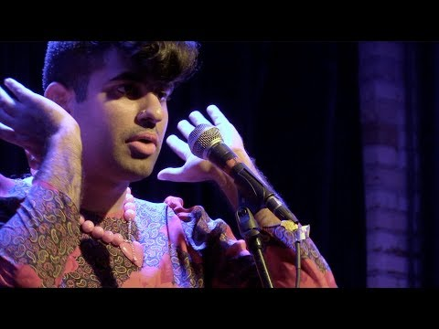
(Video)

Works cited
video. 2020, https://youtu.be/VLeObePNRa8?t=216. Accessed 31 July 2020.
2020, https://www.masterclass.com/articles/how-to-write-spoken-word-poetry.Accessed 31 July
2020.

